**DAY -2**

'''

AlphaCipher is a string formed from another by rearranging its letters

You are given two strings A and B,

Print true, if B is an AlphaCipher of A,

Otherwise false

Input Format:

-------------

Two space separated strings, A and B

Output Format:

--------------

Print a boolean value.

Sample Input-1:

---------------

dormitory dirtyroom

Sample Output-1:

----------------

true

Sample Input-2:

---------------

listen silent

Sample Output-2:

----------------

true

Sample Input-3:

---------------

car rat

Sample Output-3:

----------------

false

=== Write your **python** code below ===

'''

**My soln:**

ss=input().split()

s=ss[0]

s1=ss[1]

res1=''.join(sorted(s))

res2=''.join(sorted(s1))

if(res1==res2):

print("true")

else:

print("false")

**Optimized soln:**

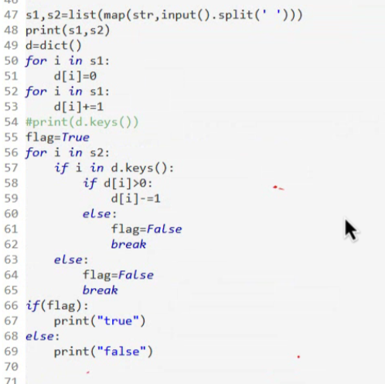

Chhota Bheem is fond of Laddus, there are N Laddus in a row, N is an even number.

Where k-th laddu is of type-laddu[k], 1<=k<=N.

Due to health issues, Chhota Bheem was suggested to eat atmost N/2 Laddus of

different types. He can eat only 1 Laddu of each type.

You are given an list of integers,

Your task is to find the maximum number of Laddus, Chhota Bheem can eat.

Input Format:

-------------

Line -1:An integer N, represents number of Laddus.

Line-2: N space separated integers, Laddu types.

Output Format:

--------------

Print an integer result.

Sample Input-1:

---------------

6

2 4 1 2 3 4

Sample Output-1:

----------------

3

Explanation:

------------

There are 6 Laddus, and 4 types of Laddus,

So Bheem can eat 3 laddus only.

Sample Input-2:

---------------

8

1 1 1 2 1 2 1 1

Sample Output-2:

----------------

2

Explanation:

------------

There are 8 Laddus, and 2 types of Laddus,

So Bheem can eat 2 ladddus only.

**My soln:**

import java.util.*;

public class Main{

public static void main(String[] args){

Scanner sc=new Scanner(System.in);

int n=sc.nextInt();

int[] arr=new int[n];

for(int i=0;i<n;i++){

arr[i]=sc.nextInt();

}

Set<Integer> k=new HashSet<>();

for(int i=0;i<n;i++){

k.add(arr[i]);

}

if(k.size()>n/2){

System.out.println(n/2);

}

else{

System.out.println(k.size());

}

}

}

AlphaCipher is a string formed from another string by rearranging its letters.

You are given a string S.

Your task is to check, can any one of the AlphaCipher is a palindrome or not.

Input Format:

-------------

A string S

Output Format:

--------------

Print a boolean value.

Sample Input-1:

---------------

carrace

Sample Output-1:

----------------

true

Sample Input-2:

---------------

code

Sample Output-2:

----------------

False

